**Outline of hands-on session 1**

**Objectives for the session:**

1. **Learn to connect to the database server and set up your MySQL account (remote server)**
2. **Get familiar with the interface of HeidiSQL**
3. **Learn to upload a database file (.sql) to MySQL server**
4. **Learn to create, drop a database and change default database**
5. **Learn to create, drop a table and change default table**
6. **Become familiar with both HeidiSQL and VDI environment**

**Task 1: Connect to MySQL server**

* If you are using **your own computer**
  + You need to use VDI to access the course database.
  + Instruction on how to use VDI is available at “Method to access course database server via VDI.docx”, which can be downloaded from Mycourse.
  + MySQL should have already been installed for you in VDI. But you need to install HeidiSQL at VDI by yourself.
* If you used **a computer from the lab** (you cannot open VDI at a university computer, since they are the same thing)
  + Please install HeidiSQL (<https://www.heidisql.com/download.php>) to the computer. MySQL should have been installed at the computers in the lab.
* After installing HeidiSQL, please
* Open HeidiSQL
* Set up your MySQL account

1. **Your account will be valid for a limit period of time (e.g. 3 months). Please don’t upload your own research data to the server.**
2. **Database IP: johnson.org.aalto.fi**
3. **Port: 3306**
4. **User ID: student number password: P + student number**

For instance, if your student number is 111111, your user ID will be 111111, and password will be P111111. Your database name will automatically be d111111 (you will see your database later after a successful login). Please **do not delete your *database* (i.e. d111111)**, however deleting *tables* is fine.

1. **If your account does not work, please contact me or course assistant ASAP and you will get a workable account immediately.**

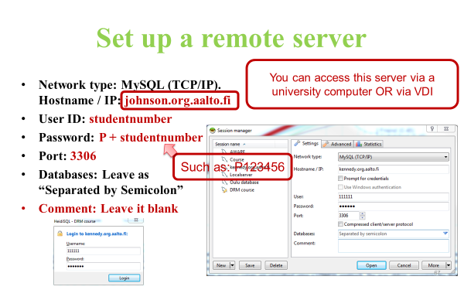

Please note that, please avoid empty space in database IP address of “johnson.org.aalto.fi”. Otherwise, it will give an error message.

**Task 2:** **Get familiar with the basic interface of HeidiSQL**

The place for entering MySQL code

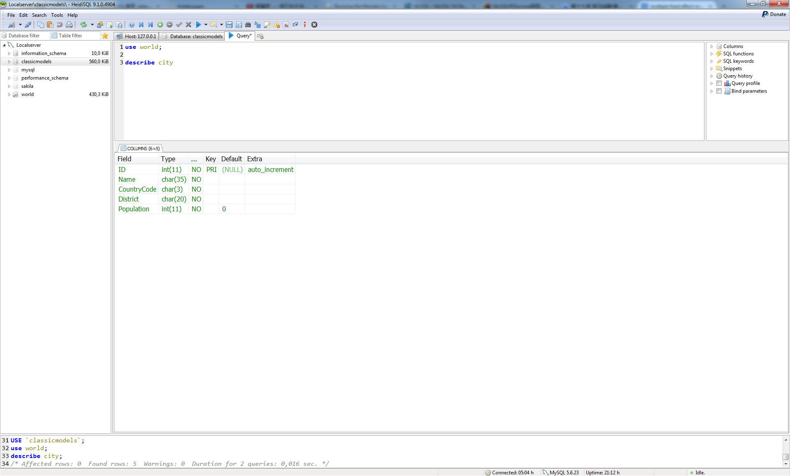

**Command**

**Output**

**Report**

**Reproduction of the MySQL code, error message, statistic of MySQL query output**

Output of MySQL query

Variable lists and history, etc.

Database and tables

**Menu**

**Task 3: Get familiar with the code to create, drop a database and change default database**

- Note that you cannot do the task 3 via your account, as a normal user (not administrator). Task 3 can only be done if you installed MySQL to your own computer and created a root account (as administrator). However, you can still read the following instructions in order to gain relevant knowledge on how to do the task. You could also try to do these operations, even though the server will reject your operations due to the permission issues.

1. **Create database -- Solution 1:**

* Right click the ‘dolphin’ sign

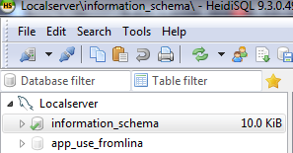

* Choose “Create new”🡪 “database”
* Enter the name of new database at: 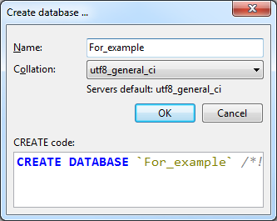
* Collation: default option
  + “**CREATE DATABASE** ‘for_example’ in the figure above shows the MySQL command that creates a new database

1. **Create database -- Solution 2: using MySQL commands**

* Type:“**CREATE** **DATABASE** for_example” in MySQL’s command window.

To operate/run a command, you need to click the blue triangle as depicted below:

**- “Run”** means run ALL the commands in the command window.

- “**Run** **Selection**” means that HeidiSQL will only run the commands that you selected.

- “**Run current query**” means that HeidiSQL will only run the command that your cursor is located.

- Note that you can use fast key (e.g. Ctrl + F9) to run commands.

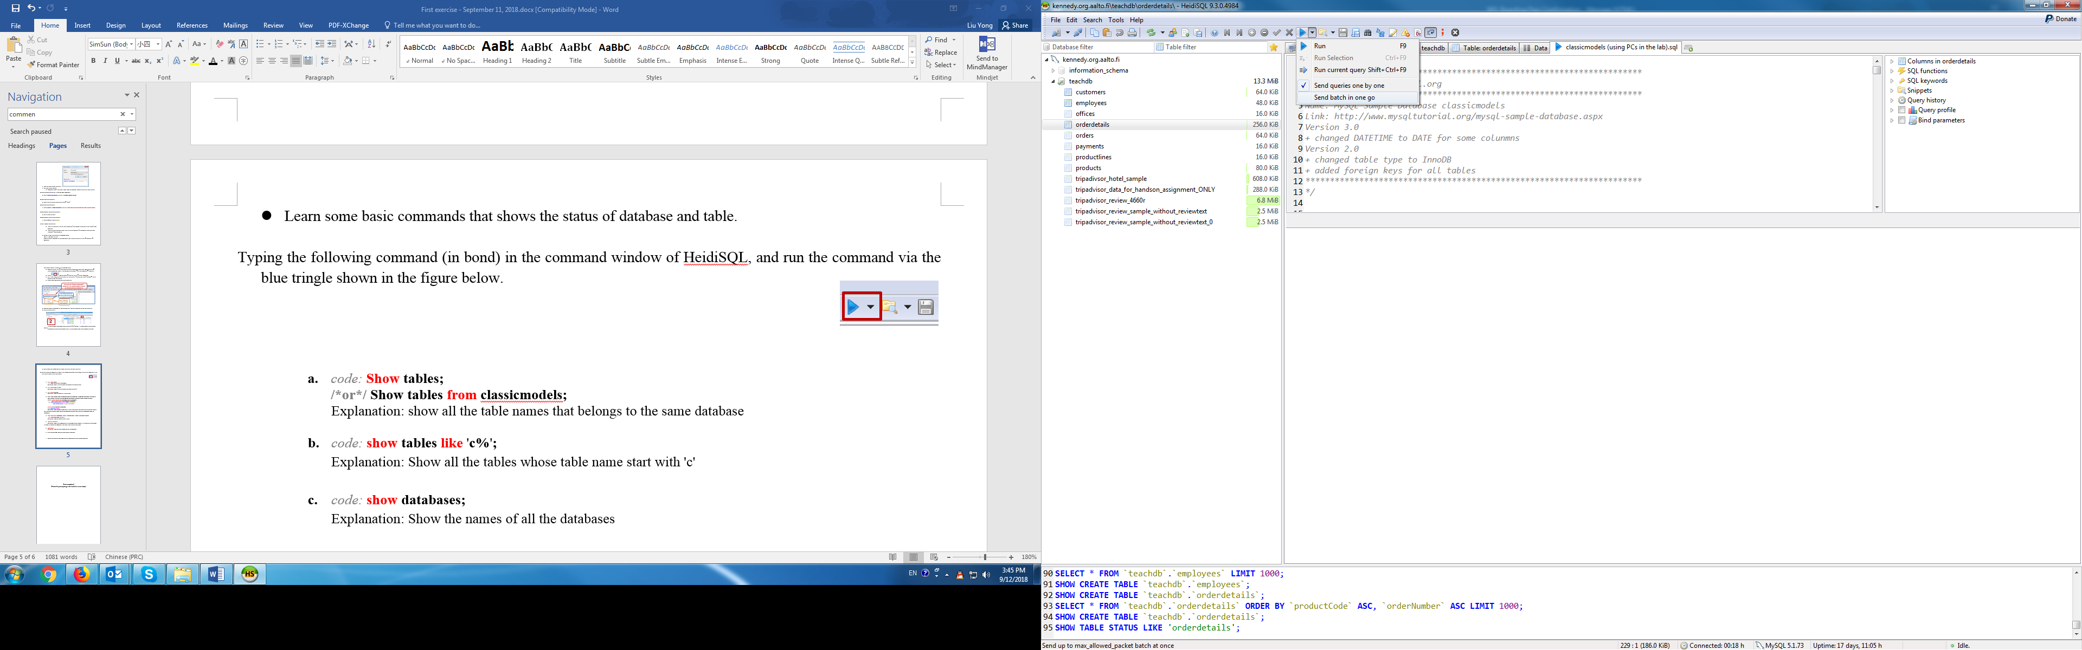

1. **Drop database -- Solution 1: [Don’t actually drop your course database. This is just to show you how to do it in the future when necessary]**

* **Right** click the database you want to drop 🡪 “drop”

1. **Drop database -- Solution 2: [Don’t actually drop your course database. This is just to show you how to do it in the future when necessary]**

* Command: **DROP** **DATABASE** for_example

1. **Change default database -- Solution 1:**

* **Left** click the database that you want to use [you have actually two databases]

1. **Change default database -- Solution 2:**

* Type command: **use** for_example

**Task 4: Import database file**

* + Please download “**classicmodels (using PCs in the lab or at home).sql**” from Mycourse page. We will import this file to the server.
* **Learn to view a MySQL database file**

What is a MySQL data file?

– You can open a MySQL file using Wordpad (right click the database file (.sql) 🡪 open with 🡪 Wordpad)

* **Learn how to import a database file to MySQL server**
* First solution: Double click .sql file, 🡪 selecting the database account that you wish to import the data to🡪 relevant commands appear at the MySQL’s command window 🡪 run the commands 🡪 completed!
* Second solution: Select \\home.org.aalto.fi\liuy13\windows\AppData\Roaming\Tencent\Users\37155891\QQ\WinTemp\RichOle\A7B6]%$}_Z~$R_0@7L5{2`0.png from the menu 🡪 select and double click the sql file 🡪 run the commands
* **NOTE**: **If you cannot see your database file from the “database and tables” window after importing the database file**, right click at any empty place of the “database and tables” window 🡪 select ‘Refresh’ or push the “F5” button. Every time when you import a database file, or create or drop a table, perform this operation to refresh your table list.

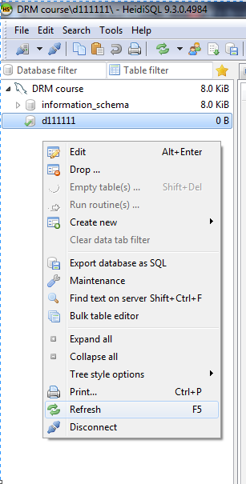

* Please **avoid repeatedly uploading** the file to the database. If it happened, just delete all the tables and import the file again.

**You cannot use “information_schema” database, because it is a system database for recording information generated by your operations**

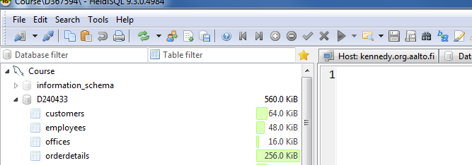

**That is the data (or tables) that you have imported**

**This PLACE shows you database name, which might be different for different users**

* Now you know that MySQL can import **multiple** **data tables** by just importing just one **database** **file** in one shot.
* **Learn to view the data**

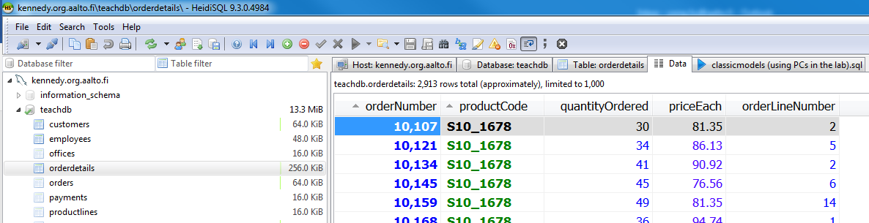

**1**

**2**

a) In HeidiSQL, please first click a table [1], as shown above.

b) Thereafter, please click the “data” button [2] to see the data pertinent to a specific table. You can click different tables to see data saved at different tables.

* Some basic commands that show the status of database and table.   
  - Please remember you need to run the selected query to get some output; the code does not automatically run by itself.  
  - Please remember to use **;** to indicate the end of a query.  
  - Please note that if you write multiple queries in the window and click the “RUN” button, MySQL will operate all the queries in the window. If you want to operate just one of them, please use “run selection” or “run current query”.

1. *code:* **Show tables;**

Explanation: show the names of all the tables that belong to the same database

1. *code:* **show tables like** '**c%**'**;**

Explanation: Show all the tables whose table names start with 'c'. You may try other letters other than 'c'.

1. *code:* **show databases;**

Explanation: Show the names of all the databases listed to your account.

1. **Task**: show columns information of a table that belongs to a specific database.  
   Table_name here means the name of your targeted table, while database_name here means the name of your targeted database.

Such as: **show columns from table_name from database_name;**

**OR show columns from database_name.table_name;**

*code:* **show** **columns** **from** customers**;**

**OR show** **columns** **from** customers **from** classicmodels **;**

**OR show** **columns** **from** classicmodels.customers**;**

**Note that** your database name should not be “classicmodels”, but ‘d+studentnumber’

**describe database_name.table_name;**

*code:* **describe**customers**;**

Explanation: Show columns information of a table [if you activate a database to be the default database (e.g. click on the database before entering the command), you don’t need to write database_name before the table_name]

1. **show index from table_name; [we will explain what index is in future class]**

*code:* **show** **index** **from** customers**;**

Explanation: Show the index used at a table

1. **show full processlist;**

Explanation: Show all the commands that are operated at the MySQL server. It is also possible to see whether any other users are operating a command at the server, depending on whether you have the permission (as administrator) to see or not.

1. **show errors;**

Explanation: Show the errors produced by your previous commands. If you don’t encounter any error message, no result will be returned.

1. **Tailor the HeidiSQL interface to your personal preference**. You can change the display of HeidiSQL interface via clicking “tools” and then make changes at “Preferences”

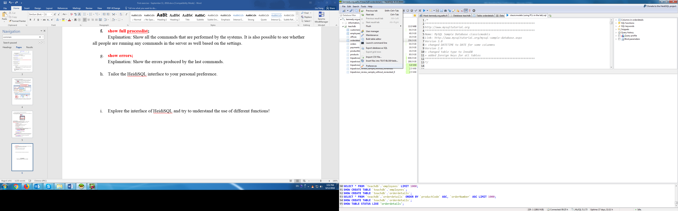

**Task 5: Explore the interface of HeidiSQL and try to understand the purposes of different functions.**

**Task 5.1:** where can you find the file size for the table orderdetails?

Answer is available at the file “Answers for first exercise - task 5.docx”

**Task 5.2:**

Please click ‘Host: johnson.org.aalto.fi’ 🡪 “Processes”, what can you see?

Without closing your current interface of HeidiSQL, open another window of software HeidiSQL again. In other words, open your database account again without closing the current one. Please see figure below.

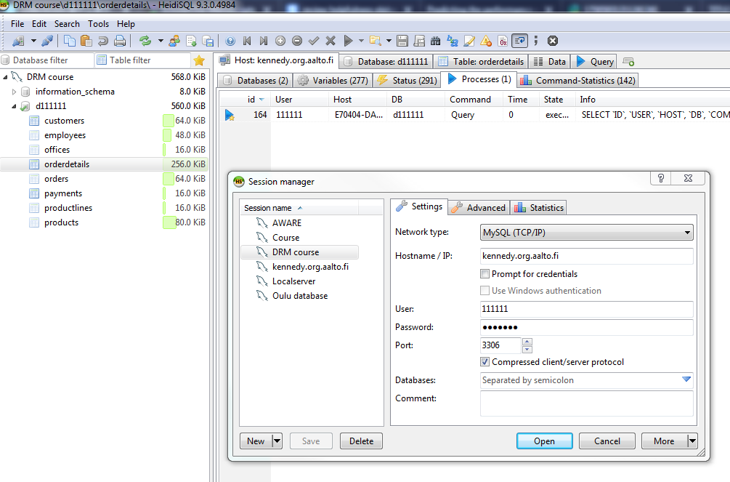

After opening your account via two different interfaces, you can see something similar to the figure below.

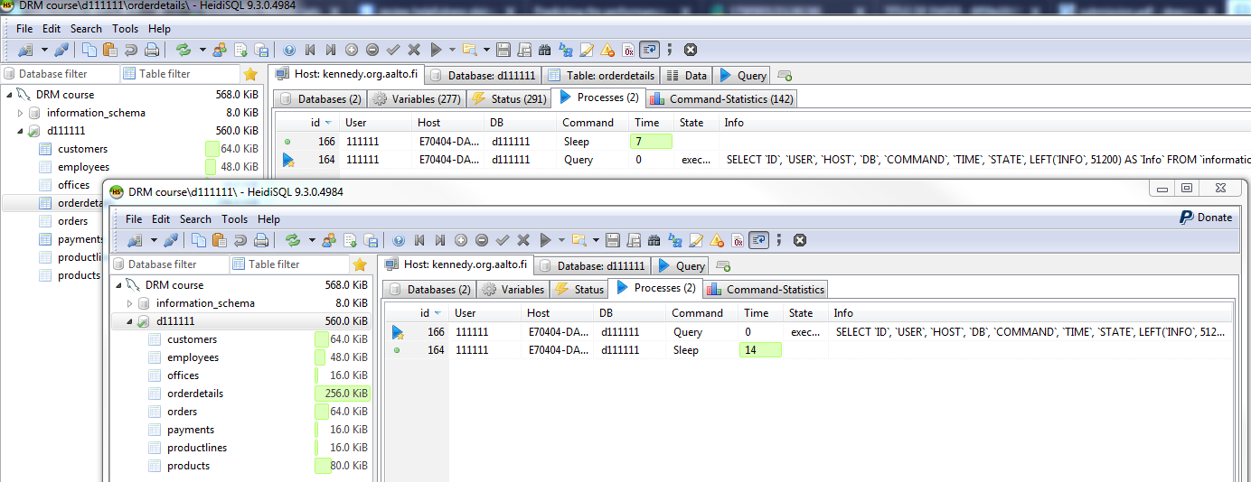

If we consider two different interfaces as two different users, please see whether you can ‘kill’ another account’s (or your own) command via your account.

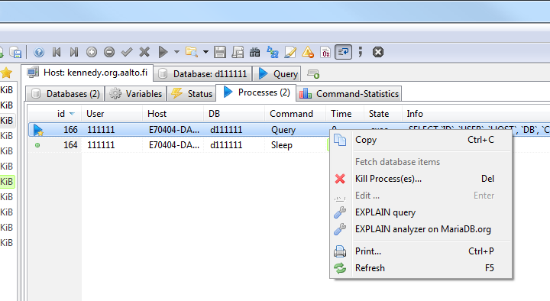

You probably see no apparent change for another account, since it just stops to show the data of a table, but if another account is running or stuck with some resource-consuming command. This is the way to free the server occupied by a resource-consuming command.

This is a very useful function to help you release a server from being overburdened with your own or other people’s queries. Think about the following scenarios – you are working in a big company with a huge amount of data (e.g. calculating the daily sale of supermarkets in Finland on a basis of millions of receipt data). It is normal that some complex commands may take hours to operate. After having a command operating in the server for several hours, you may want to cancel your operation to release the server due to various reasons like a wrong query or server being too slow, etc. In this vein, you can cancel your query via the above-mentioned operation.

**Task 5.3:**

Please check the data of the table ‘orderdetails’, you can see only the ***first*** 1,000 rows of the data of this table, as shown in the figure below.

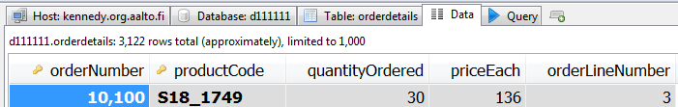

* How can you exhibit the ***next*** 1,000 rows of the data?
* Can you exhibit all the data?

Answer is available at the file “Answers for first exercise - task 5.docx”

**Task 5.4:**

After browsing the data of a table, you feel the font size is too small and don’t like its font type as well. How can you change the font size and font type of data?

Answer is available at the file “Answers for first exercise - task 5.docx”

**Task 5.5**:

After typing many commands in the command window, you may realize that there are too many texts in the command window and you want to *remove them all*. It is possible to do the above task via a simple operation. By double clicking “Query” button showing below, you will obtain a clean/empty command window.

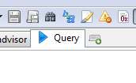

**Tasks completed!   
Thanks for participating in the first hands-on session!**